

**SDP-100**

**Project Title:** Library Management System project.

**Submitted to Submitted By**

Name: MD. MASUDUL ISLAM Team Name: System404

Asst. Professor Name: Md. Shafiul Azam

Department of CSE ID: 21225103132

Name: Md. Alin Ahmed Foysal

ID: 21225103124

Name: Salauddin Ahmed

ID: 21225103131

Name: Iffat Tahsin

ID: 21225103129

**Idea:** Management is a project that manages and preserves electronic books, Books data based, Medical store data based, on the library demands of students. Both students and library administrators can use the system to keep track of all the books available in the library. It allows both the administrator and the student to look for the desired book price data etc.

**FEATURES:**

* **Library Management System Projects.**

**PROPOSED SYSTEM**

Proposed system is an automated Library Management System. Through our software user can add members, add books, search members, search books, update information, edit information, borrow and return books in quick time. Our proposed system has the following advantages.

• User friendly interface

• Fast access to database

• Less error

• More Storage Capacity

• Search facility

• Look and Feel Environment

• Quick transaction

All the manual difficulties in managing the Library have been rectified by implementing computerization.

**TOOLS, TECHNOLOGY AND SOFTWARE:**

* At Last a PC.
* Monitor.
* Keyboard.
* Mouse.
* Hard Disk.
* Structured Programming Language C.
* Operating system: Windows 10 pro.
* CodeBlocks 20.3, Visual Studio Code, MS Word.

**ACTIVITIES:**

• Search for a books.

• Add/Delete books.

• Maintain the database.

• View user details.

• Issue books.

• Return books.

• Maintain user details.

**PROCESSING:**

**Login**  
I have created this function to enable the user and the admin login. So, initially when a user logs in for the first time, that user will be an admin by default, and the username and password will be {admin, admin}. Refer below.

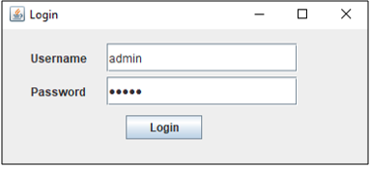

For this schema, I have considered only one admin. So, once a user logs in as an admin, he or she will be redirected to the admin menu as below. I will discuss the functions of the admin in the [admin menu](https://www.edureka.co/blog/library-management-system-project-in-java#AdminMenu) section.

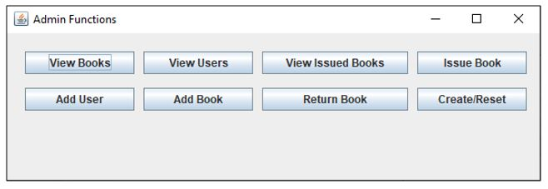

**In-Code:**

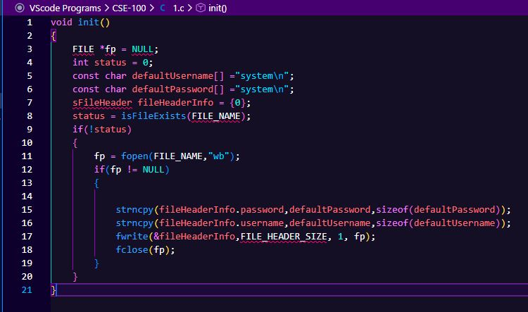

|  |  |  |
| --- | --- | --- |
| **ID:21225103124** | **Task** | **Time** |
| **Code and Design** |
| **22, August 2022-5hours** |
| **23, August 2022-4hours** |
| **24, August 2022-3hours** |
| **25, August 2022-5hours** |

|  |  |  |
| --- | --- | --- |
| **ID:21225103132** | **Task** | **Time** |
| **Code and Design** |
| **22, August 2022-4 hours** |
| **23, August 2022-3hours** |
| **24, August 2022-5hours** |
| **25, August 2022-3hours** |

|  |  |  |
| --- | --- | --- |
| **ID:21225103131** | **Task** | **Time** |
| **Code** |
| **22, August 2022-3hours** |
| **23, August 2022-2hours** |
| **24, August 2022-4hours** |
| **25, August 2022-2hours** |

|  |  |  |
| --- | --- | --- |
| **ID:21225103129** | **Task** | **Time** |
| **Code** |
| **22, August 2022-3hours** |
| **23, August 2022-3hours** |
| **24, August 2022-2hours** |
| **25, August 2022-3hours** |